


Impact of Generative AI on Academic Performance and Burnout
A Data-Driven Analysis of Academic Outcomes and Student Well-being

Team Number: 10
Team Members:
- Shreya Srinivasan (IIMSI_EDGE_2511198)
- Kumkum Bathri (IIMSI_EDGE_2511038)
- Akash Raj Nigam (IIMSI_EDGE_2511002)
- Eklavya Singh (IIMSI_EDGE_2511102)
- Anushi Pandey (IIMSI_EDGE_2511064)
- Kaustubh Giridhar (IIMSI_EDGE_2511182)
Date: 30 July 2026

Executive Summary
Generative Artificial Intelligence (GenAI) is rapidly transforming how university students learn, research, and complete academic tasks. While AI offers significant opportunities to enhance learning efficiency and academic performance, its increasing use has also raised concerns regarding excessive dependency, reduced independent learning, and student burnout. This study investigates the academic and behavioural impact of Generative AI on university students by examining the factors influencing academic performance and severe burnout.
A structured data analytics approach was adopted using a dataset of 50,000 university students. Following data preprocessing, exploratory data analysis, and feature engineering, Multiple Linear Regression was used to identify factors associated with students' Post-Semester GPA, while Binary Logistic Regression was employed to predict the likelihood of severe burnout.
The findings indicate that effective AI usage — particularly strong Prompt Engineering skills and learning-oriented AI applications — is positively associated with academic performance, whereas greater AI dependency, intensive AI engagement, examination anxiety, and increasing study workload are associated with a higher likelihood of severe burnout. Traditional study habits continue to play an important role in academic success, suggesting AI should complement rather than replace independent learning.
The findings provide practical insights for universities and educators to develop evidence-based strategies that promote responsible AI adoption, strengthen AI literacy, redesign assessments for higher-order learning, and implement early-intervention mechanisms to support student well-being.

Business Problem
The rapid integration of Generative Artificial Intelligence (GenAI) into higher education has transformed the way students learn, complete assignments, and prepare for examinations. While AI offers significant opportunities to enhance learning and improve academic outcomes, it has also raised concerns regarding excessive dependence, changing study habits, and student well-being. Educational institutions therefore require empirical evidence to understand how AI usage and dependency influence both academic performance and burnout among students.
This study addresses these concerns from two complementary perspectives:

Objective 1 — University Perspective
How do AI usage patterns, study habits, and academic characteristics influence students' Post-Semester GPA? A Linear Regression model is developed to examine this relationship and evaluate the role of AI-assisted learning in higher education.

Objective 2 — Student Perspective
Which behavioural, academic, and AI-related factors are significantly associated with the risk of high burnout in students? A Binary Logistic Regression model is developed to identify factors most strongly associated with burnout and support initiatives that improve student well-being.

Research Objectives
- Develop a Multiple Linear Regression model to examine how AI usage patterns, study habits, and academic characteristics influence students' Post-Semester GPA.
- Develop a Binary Logistic Regression model to identify the factors associated with severe student burnout.
- Compare the impact of AI usage on academic performance and psychological well-being.
- Recommend strategies for educational institutions to promote responsible AI usage while supporting academic success and student well-being.

Dataset Description

Dataset Overview
The study uses the AI Impact on Students dataset obtained from Kaggle, containing information on students' academic performance, AI usage patterns, study habits, prompt engineering skills, institutional policies, and burnout risk — selected for its coverage of both academic and behavioural characteristics.
Property | Description
Population | University students
Rows | 50,000
Columns | 16
Missing Values | None
Source | Kaggle — "AI Impact on Students" (Author: Lavesh Jadon)

Column Descriptions (16 variables)
Column | Type | Description
Student_ID | Integer | Unique identifier for each student
Major_Category | Categorical | Field of study — STEM, Business, Humanities, Medical, Arts
Year_of_Study | Categorical | Academic standing — Freshman to Graduate
Pre/Post_Semester_GPA | Float | GPA at start / end of semester (~1.0–4.0); Post-GPA is the primary outcome variable
Weekly_GenAI_Hours | Float | Average hours/week using Generative AI tools (0–40)
Primary_Use_Case | Categorical | Main purpose of AI use — Drafting, Summarizing, Debugging, Ideation, Direct Answers
Prompt_Engineering_Skill | Categorical | Self-assessed prompting proficiency — Beginner/Intermediate/Advanced
Tool_Diversity | Integer | Number of distinct AI tools used (1–5)
Paid_Subscription | Boolean | Whether the student holds a paid AI subscription
Traditional_Study_Hours | Float | Weekly hours devoted to non-AI study methods (1–36)
Perceived_AI_Dependency | Integer | Self-rated dependency on AI, scale 1 (low)–10 (high)
Institutional_Policy | Categorical | Institution's stance — Allowed with Citation, Strict Ban, Actively Encouraged
Anxiety_Level_During_Exams | Integer | Self-reported exam anxiety, 1 (minimal)–10 (severe)
Skill_Retention_Score | Float | Score (0–100) measuring retention of learned skills post-semester
Burnout_Risk_Level | Categorical | Assessed burnout risk — Low, Medium, High

Methodology

Research Methodology
This study follows a structured data analytics framework: data collection, preprocessing, exploratory data analysis, feature engineering, model development, model evaluation, and interpretation of findings. Two statistical models were developed — a Multiple Linear Regression model for Post-Semester GPA, and a Binary Logistic Regression model for severe student burnout.
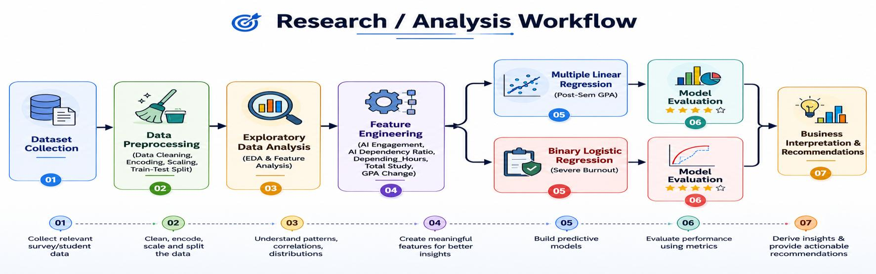
Figure 1. Research / Analysis Workflow

Data Preprocessing
- Data Inspection: Imported via Pandas; info(), describe(), isnull().sum() confirmed no missing values.
- Data Cleaning: Student_ID removed (no analytical value); outliers in Traditional_Study_Hours (>32 hrs) removed.
- Encoding: Nominal variables one-hot encoded; Booleans converted to binary; ordinal variables (Year_of_Study, Prompt_Engineering_Skill, Burnout_Risk_Level) encoded by natural order. One dummy per nominal feature dropped to avoid multicollinearity.
- Feature Scaling: Continuous predictors standardised using StandardScaler.
- Train-Test Split: 60% training / 40% testing, with stratified sampling for the classification model.

Exploratory Data Analysis (EDA)
EDA was performed to understand dataset characteristics, identify variable relationships, and obtain preliminary insights before model development. The analysis included:
- Dataset inspection and descriptive statistics
- Distribution analysis using histograms and Kernel Density Estimation (KDE)
- Outlier detection using boxplots
- Frequency analysis of categorical variables using count plots
- Pearson and Spearman correlation analysis
- Scatter plots and boxplots examining predictor relationships with Post-Semester GPA
- KDE plots analysing predictor distributions across burnout categories
- Variance Inflation Factor (VIF) analysis to assess multicollinearity

Feature Engineering
Several derived variables were engineered to better represent students' learning behaviour and AI usage patterns, capturing relationships the original variables could not represent alone:
Feature | Definition | Purpose
Depending_Hours | Weekly_GenAI_Hours × Perceived_AI_Dependency (mean-centred) | Interaction of AI usage and perceived dependency
AI_Engagement | Weekly_GenAI_Hours × Tool_Diversity × Prompt_Engineering_Skill | Overall intensity/effectiveness of AI usage
AI_Dependency_Ratio | Weekly_GenAI_Hours ÷ (Traditional_Study_Hours + 1) | Reliance on AI relative to traditional study
Total_Study | Weekly_GenAI_Hours + Traditional_Study_Hours | Overall study effort
GPA_Change | Post_Semester_GPA − Pre_Semester_GPA | Change in academic performance
Is_Burn_Out | High = 1, Low/Medium = 0 | Binary severe-burnout target variable

Model Development & Evaluation
Model 1 (OLS Linear Regression) estimates each predictor's contribution to Post-Semester GPA, evaluated via R², Adjusted R², MAE, RMSE, MAPE, F-statistic, residual analysis, and p-values. Model 2 (Binary Logistic Regression, MLE-estimated) estimates the probability of severe burnout, evaluated via accuracy, precision, recall, F1-score, confusion matrix, ROC-AUC, and coefficient significance.

Analysis and Findings

Model 1: Multiple Linear Regression — Post-Semester GPA
Objective: predict Post-Semester GPA to help universities understand how AI-assisted learning and study behaviours influence academic performance, supporting evidence-based policy. Dependent variable: Post_Semester_GPA. Predictors include Year_of_Study, Pre_Semester_GPA, Weekly_GenAI_Hours, Prompt_Engineering_Skill, Traditional_Study_Hours, Perceived_AI_Dependency, Anxiety_Level_During_Exams, AI use-case dummies, and the Depending_Hours interaction term.
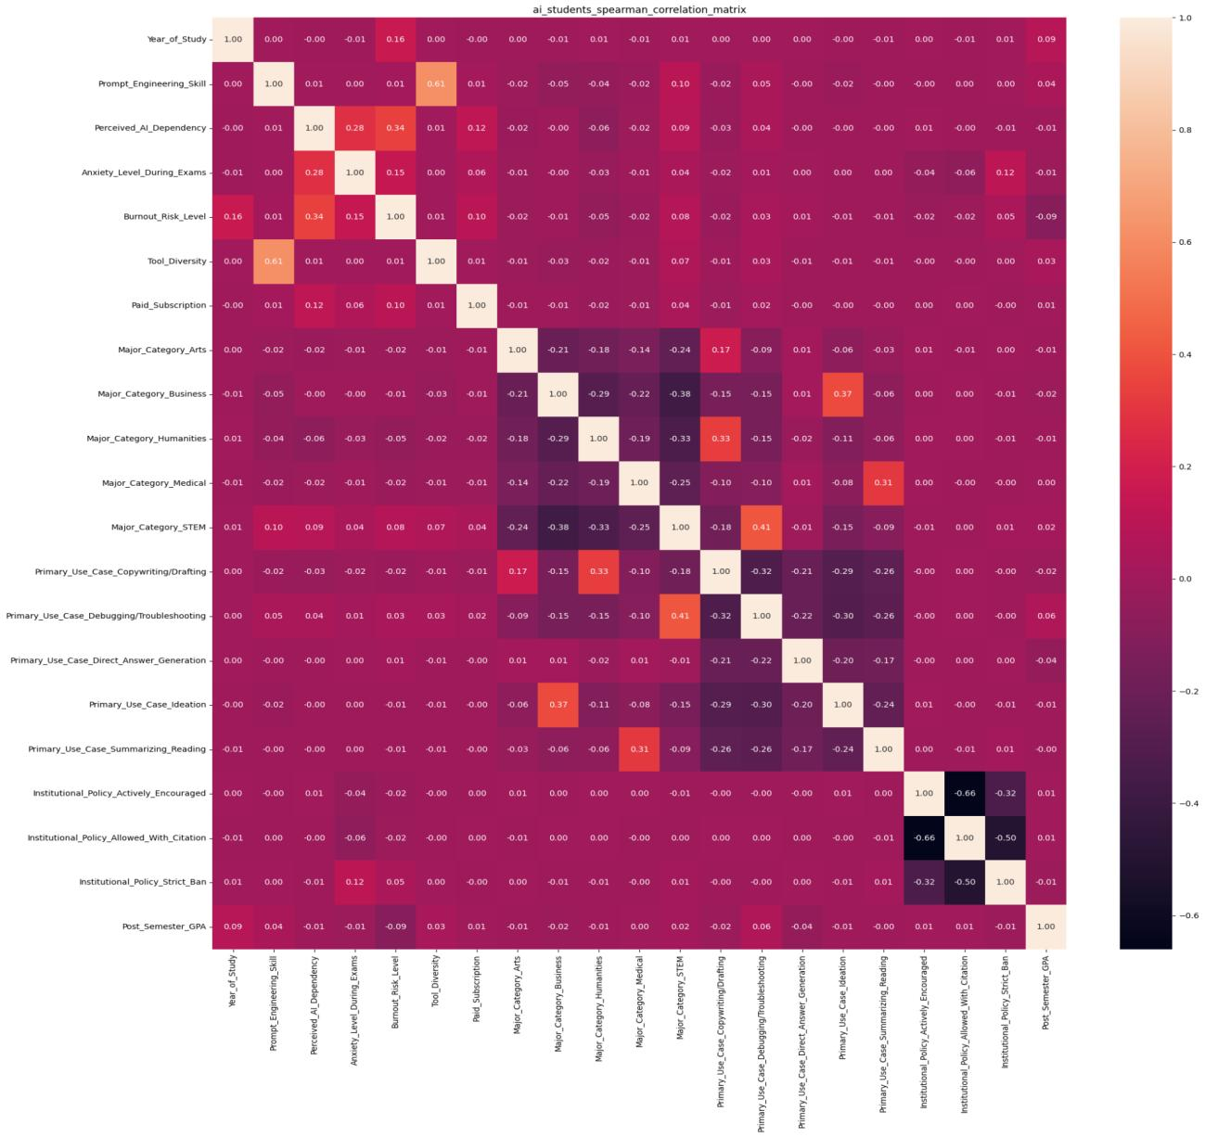
Figure 2. Spearman correlation heatmap of predictors
Most predictors show weak individual correlation with Post-Semester GPA, supporting a multivariate regression approach. Prompt Engineering Skill and Tool Diversity correlate moderately (ρ = 0.61); Perceived AI Dependency correlates moderately with Burnout Risk (ρ = 0.34); and Anxiety During Exams correlates with AI Dependency (ρ = 0.28). Most other correlations are below |0.30|, indicating limited multicollinearity risk.

Model Fit
Metric | Value
Observations | 29,999
R² | 0.895
Adjusted R² | 0.895
F-statistic | 2.615e+04 (p < 0.001)
Covariance Type | HC3 (robust standard errors)

The model explains ~89.5% of the variation in Post-Semester GPA; the F-test confirms overall statistical significance. HC3 robust errors were used since heteroscedasticity was detected in residual diagnostics (see figure below).

Regression Coefficients
Predictor | Coefficient (β) | p-value
Constant | 3.3493 | <0.001
Year_of_Study | 0.0440 | <0.001
Pre_Semester_GPA | 0.4607 | <0.001
Weekly_GenAI_Hours | 0.0161 | <0.001
Prompt_Engineering_Skill | 0.0230 | <0.001
Traditional_Study_Hours | 0.0708 | <0.001
Perceived_AI_Dependency | -0.0011 | 0.364
Anxiety_Level_During_Exams | -0.0057 | <0.001
Primary_Use_Case_Debugging/Troubleshooting | 0.0205 | <0.001
Primary_Use_Case_Direct_Answer_Generation | -0.0226 | <0.001
Depending_Hours (interaction) | -0.0194 | <0.001

Key Findings
- Pre_Semester_GPA (β = 0.4607): strongest positive predictor — prior academic performance carries forward strongly.
- Traditional_Study_Hours (β = 0.0708): conventional study habits remain important.
- Prompt_Engineering_Skill (β = 0.0230) & Weekly_GenAI_Hours (β = 0.0161): effective, moderate AI use supports learning.
- Debugging/Troubleshooting use (β = 0.0205): learning-oriented AI use is linked to slightly higher GPA.
- Direct_Answer_Generation (β = −0.0226) & Depending_Hours interaction (β = −0.0194): relying on AI for direct answers, or combining heavy AI usage with high dependency, is linked to lower GPA.
- Perceived_AI_Dependency alone (p = 0.364): not significant by itself — its effect only emerges through the interaction with usage hours.
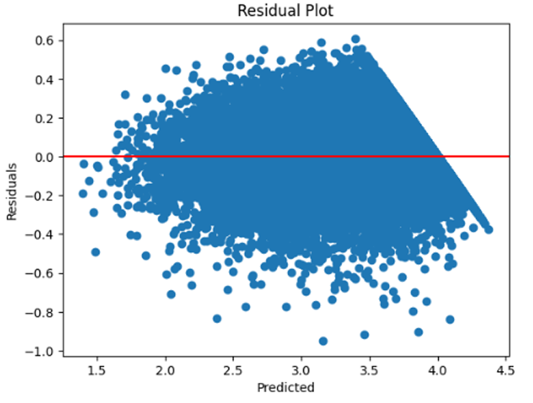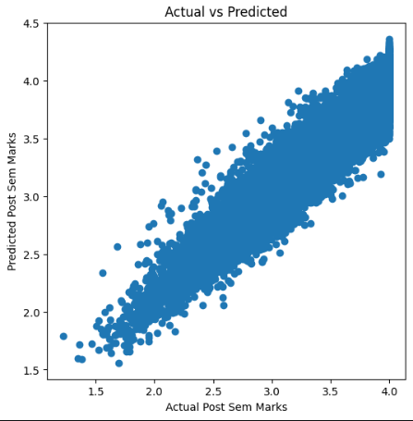
Figure 3. Residual plot (left) and Actual vs. Predicted GPA (right)

Interaction Effect
Perceived_AI_Dependency was retained to test its interaction with Weekly_GenAI_Hours. While not significant on its own (p = 0.364), the interaction term Depending_Hours is significant and negative (β = −0.0194, p < 0.001) — meaning higher AI usage hours combined with greater dependency is associated with lower GPA, even though dependency alone does not significantly affect performance.

Strategic Implications
Strategy Area | Insight from Model | Business Action
Curriculum | Prompting skill > time spent | Mandate AI-literacy training
Product Design | Direct answers hurt performance | Design AI tutors to give hints, not answers
Risk Management | High dependency → higher burnout | Flag high-dependency users for academic support
Messaging | Traditional study still drives GPA | Reinforce AI as a secondary aid to core study

Model Assumptions & Limitations
- Association, not causation: relationships identified are statistical, not proof of direct cause.
- Self-reported data (AI dependency, prompting skill, study hours) may carry recall error or bias.
- Linear-relationship assumption may not capture more complex, nonlinear effects of AI usage.
- Limited generalizability beyond the sampled population without further validation.
- Unobserved factors (teaching quality, motivation, socioeconomic background) are not modelled.
- Residuals showed heteroscedasticity; HC3 robust standard errors were used to keep inference reliable.
Overall inference: How students use GenAI matters more than how much they use it. Strong prompt-engineering skills and learning-oriented use (debugging, concept clarification) are associated with better outcomes than direct-answer generation, and traditional study habits remain a significant, independent driver of GPA.

Model 2: Binary Logistic Regression — Severe Burnout
Objective: Identify academic, behavioural, AI-related, and psychological factors associated with severe burnout. The dependent variable, Is_Burn_Out, combines Low/Medium burnout as 0 and High burnout as 1 — chosen after EDA revealed substantial overlap between the Low and Medium categories. Predictors: Anxiety_Level_During_Exams, Year_of_Study, Tool_Diversity, AI_Engagement, AI_Dependency_Ratio, Total_Study, Perceived_AI_Dependency, Skill_Retention_Score, and Pre_Semester_GPA. All predictor VIF values were below 3, indicating no problematic multicollinearity.

Model Fit
Metric | Value
Observations | 29,999
Pseudo R² (McFadden) | 0.2013
Log-Likelihood | -13,467 (LL-Null: -16,861)
LLR p-value | < 0.001
Convergence | Successful (6 iterations, MLE)

Regression Coefficients
Predictor | Coefficient (β) | p-value
Constant | -1.3027 | <0.001
Anxiety_Level_During_Exams | 0.0973 | <0.001
Year_of_Study | 0.3767 | <0.001
Tool_Diversity | -0.1440 | <0.001
AI_Engagement | 0.3280 | <0.001
AI_Dependency_Ratio | 0.4495 | <0.001
Total_Study | 0.3403 | <0.001
Perceived_AI_Dependency | 0.3534 | <0.001
Skill_Retention_Score | -0.0766 | <0.001
Pre_Semester_GPA | -0.2267 | <0.001

Classification Performance
Metric | Value
Accuracy | 75.63%
Precision (High Burnout) | 51%
Recall (High Burnout) | 66%
F1-Score (High Burnout) | 57%
ROC-AUC | 0.793
Classification Threshold | 0.2579

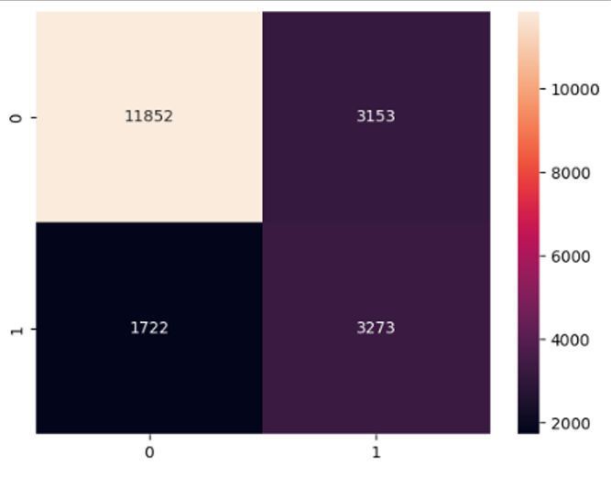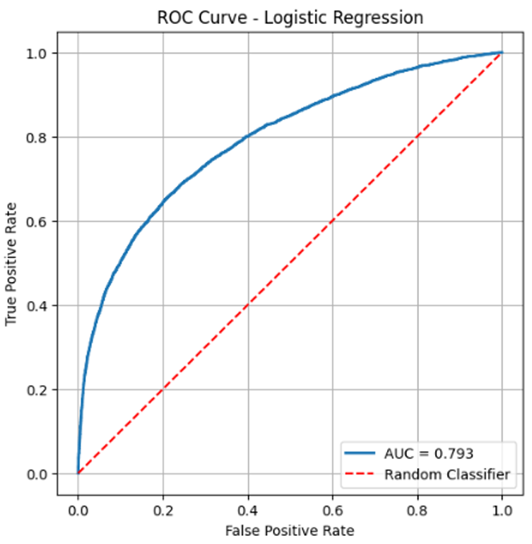
Figure 4. Confusion matrix (left) and ROC curve, AUC = 0.793 (right)
The model correctly identified 11,852 Low/Medium-burnout students and 3,273 High-burnout students, with 1,722 false negatives and 3,153 false positives. Given the goal of early intervention, this trade-off is acceptable — missing a genuinely high-risk student is more costly than an extra counselling referral.

Key Findings
- AI_Dependency_Ratio (β = 0.4495), Perceived_AI_Dependency (β = 0.3534), Year_of_Study (β = 0.3767), AI_Engagement (β = 0.3280), Total_Study (β = 0.3403): the strongest positive drivers of severe burnout — heavier, more dependent AI use combined with rising academic workload substantially raises risk.
- Anxiety_Level_During_Exams (β = 0.0973) and Pre_Semester_GPA (β = 0.226): exam anxiety and even strong prior performance (likely via higher expectations/workload) raise burnout risk.
- Tool_Diversity (β = −0.1440) and Skill_Retention_Score (β = −0.0766): protective factors — using a broader toolkit and retaining skills effectively is linked to lower burnout risk.
Overall inference: Severe burnout stems from a combination of AI dependency, academic workload, and psychological factors rather than any single cause. Diversified, purposeful AI use appears protective, while heavy, dependent use compounds burnout risk.

Model Assumptions & Limitations
- Dependent variable is binary (Is_Burn_Out); observations are independent, one record per student.
- Predictors were standardised before estimation; VIF values below 3 indicate no problematic multicollinearity.
- The model assumes a linear relationship between predictors and the log-odds of severe burnout, and may not capture complex non-linear interactions.
- Performance depends on dataset quality/representativeness; the model is sensitive to class imbalance.
- External validation is recommended before generalising to other educational settings.

Business Recommendations

1. Integrate Prompt Engineering and AI-Assisted Problem Solving into the Curriculum
Since prompt-engineering skill and debugging-oriented AI use are linked to stronger GPA, universities should formally teach prompt engineering, AI-assisted problem solving, and critical evaluation of AI output — building analytical skill rather than passive dependence.

2. Redesign Assessment Methods to Promote Higher-Order Thinking
Because reliance on direct-answer generation is linked to weaker outcomes, assessments should shift toward case studies, projects, presentations, and application-based questions that reward reasoning over answer reproduction.

3. Develop an AI Learning Analytics Dashboard for Early Intervention
Both models show academic performance and burnout can be explained by behavioural and AI-usage variables. A dashboard tracking AI Dependency Ratio, weekly AI usage, study hours, prompt skill, anxiety, and burnout probability would support timely academic-advisor intervention.

4. Establish AI Literacy and Tool Diversification Programmes
Since tool diversity is protective against burnout, universities should run periodic AI literacy workshops and tool demonstrations to reduce over-reliance on any single AI platform.

5. Introduce Progressive AI Support Across Academic Years
Since burnout risk rises with year of study, AI support should be staged — literacy and responsible-use training in early years, and research/project support paired with burnout-management resources in senior years.

Conclusion
This study examined the impact of Generative AI on university students from two complementary perspectives — academic performance and student well-being — using Multiple Linear Regression and Binary Logistic Regression. The findings demonstrate that the quality of AI usage matters more than the quantity: strong prompt-engineering skills and learning-oriented AI use are linked to better academic performance, while excessive AI dependency, intensive engagement, rising workload, and exam anxiety raise the likelihood of severe burnout. Traditional study habits remain vital, indicating that AI should complement rather than replace independent learning.
From an institutional perspective, universities should move beyond simply encouraging or restricting AI adoption, focusing instead on developing students' ability to use AI effectively and responsibly — through curriculum design, assessment strategy, learning analytics, and student support systems that balance academic performance with well-being.

References
- Kaggle. (2025). AI Impact on Students [Dataset]. Retrieved from kaggle.com/datasets/laveshjadon/ai-impact-on-students.
- statsmodels Development Team. (2025). statsmodels: Statistical modeling in Python (Version 3.12). Retrieved from statsmodels.org.

Appendix A: Sample Screenshots

A1 — Data Preview

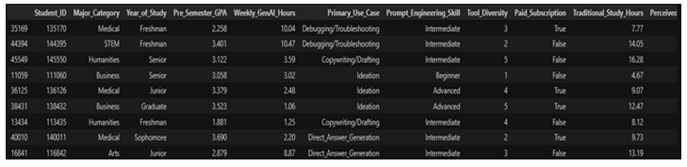

A2 — Data Structure
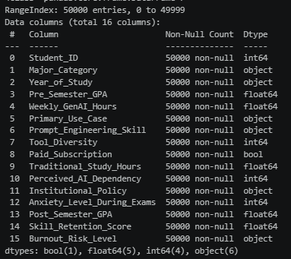

A3 — Multiple Linear Regression Summary
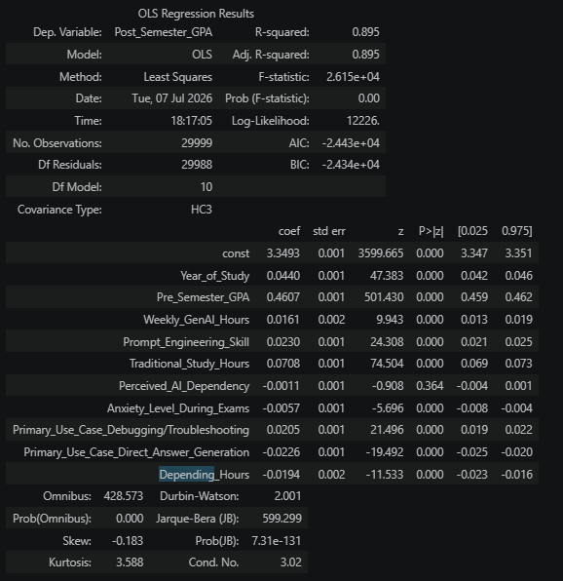

A4 — Binary Logistic Regression Summary

